Left is one of the first patents on the multi-cavity magnetron, filed in Germany in November 29, 1935 by H.E. Hollmann. The patent explains in explicit detail how the cavity magnetron works and that it can have many configurations including any even number of cells. Also stated is that a fluid is used between the outer magnet and the inner cylinder to cool the device.
Below is the patent for split-anode magnetron and its controlling circuit. Other magnetron patents by Hollmann are shown below
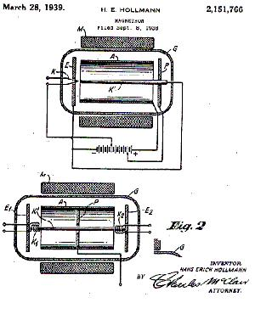
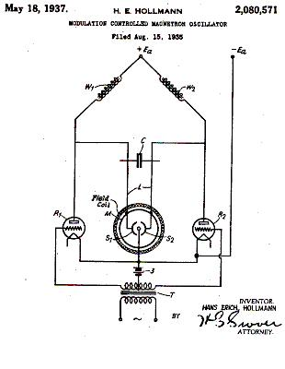
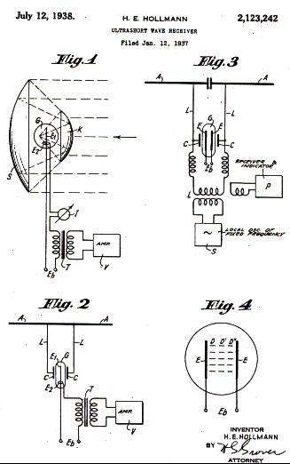
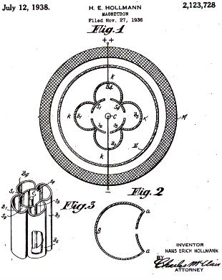

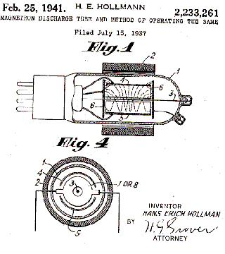
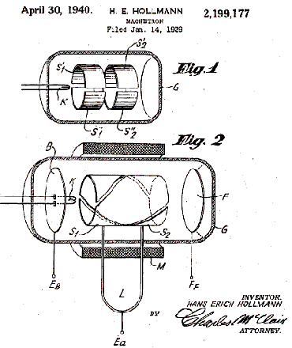
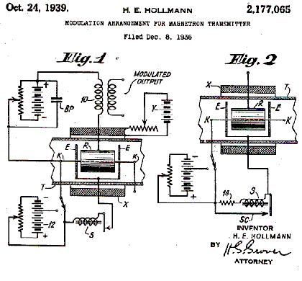
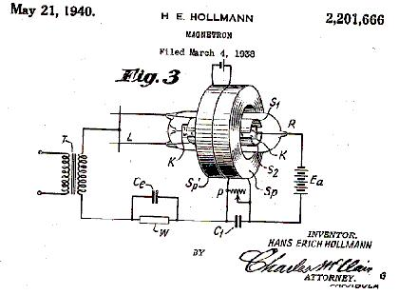
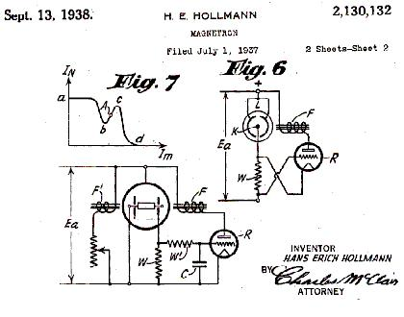
- Utra Short wave system. 1,921,187; Oct. 13, 1930
- Method and apparatus for the generation of electric oscillations. 1,962,195; May 2, 1929
- High Frequency oscillator. 1,962,196; Aug 13, 1929
- Ultrashort wave system. 1,978,021; Oct 13, 1930
- Operating electric discharge device. 1,994,219; 1930
- Ultra-short wave radio system. 2,092,069; June 8, 1935
- Modulation and frequency stabilization. 2,078,245; June 19, 1933
- Modulation - controlled magnetron oscillator. 2,080,571; Aug 31, 1934
- Modulation system for ultra-high frequency waves. 2,080,572; Aug 21, 1933
- Utra Short wave system. 1,921,187; Oct 13, 1930
- Method and apparatus for the generation of electric oscillations. 1,962,195; May 2, 1929
- Ultrashort wave system. 1,978,021; Oct 13, 1930
- Tuning device. 2,081,746; 1930
High Frequency oscillator. 1,962,196; Aug 13, 1929
- Ultra-short wave radio system. 2,092,069; June 8, 1935
- Modulation and frequency stabilization. 2,078,245; June 19, 1933

- Modulation - controlled magnetron oscillator. 2,080,571; Aug 21, 1934
- Modulation system for ultra-high frequency waves. 2,080,572; Aug 21, 1934
- Tuning receivers operating on potential resonance. 2,085,022; Aug 23, 1934
- Amplifying circuit arrangement. 2,088,061; Nov 24, 1934
- Electron tube and circuit therefore. 2,088,653; March 8, 1933
- Grid detection circuit for wave lengths below one decimeter. 2,089,260; March 6, 1935
- Automatic volume control circuit. 2,093,560; Sept. 21, 1935*
- Automatic detector gain control circuit. 2,093,561; Sept. 21, 1935*
- Tuning device. 2,081,746; May 25, 1935*
- Ultra-short wave receiver. 2,030,872; July 11, 1933
- Receiver for ultra short waves. 2,033,937; August 17, 1933
- Electron discharge device circuit. 2,044,003; March 8, 1933

- Braun tube. 2,046,513; May 30, 1932
- Large power ultra short wave generator. 2,047,204; June 30, 1933
- Large power ultra short wave generator. 2,047,205; June 30, 1932
- Magnetically controlled electron discharge device. 2,054,126; July 5, 1934
- Receiving circuit. 2,059,581; April 6, 1933
- Electronic oscillator. 2,054,816; July 10, 1929
- Recording device. 2,133,140; Oct. 11, 1938*
- Modulation system. 2,104,541; Jan. 31, 1934
- Ultrashort wave circuit. 2,111,396; March 8, 1933
- Fading elimination. 2,111,778; Aug 25, 1933
- Ultrashort wave resonance system. 2,115,070; Sept 15, 1934
- Ultrashort wave receiver. 2,123,242; July 12, 1938
- Modulation circuit for retarding field generators. 2,123,727; Nov 3, 1933
- Magnetron. 2,123,728; Nov 29, 1935
- Magnetron. 2,130,132; July 16, 1936
- Secondary emission tube and circuit. 2,138,920; April 23, 1936
- Electron discharge device. 2,144,222; Jan. 17, 1939

- Radio apparatus for determining distance and direction. 2,151,323; Mar. 21, 1939
- Device for generating electrical oscillations. 2,151,765; May 18, 1935
- Magnetron. 2,151,766; Aug 24, 1937
- Oscillator. 2,153,190; April 8, 1936
- Electromechanical oscillating device. 2,154,127; July 7, 1936
- Crystal mounting with temperature compensation. 2,157,665; Oct 17, 1935
- Cross field control tube. 2,164,922; Dec 3, 1935
- Receiver for ultra-short waves. 2,169,358; June 18, 1937
- Electron discharge device. 2,171,212; April 20, 1936
- Detector. 2,175,263; April 22, 1936
- Electron beam tube. 2,176,589; Jan 16, 1936
- Modulation arrangement for magnetron transmitter. 2,177,065; Dec 9, 1935
- Electronic device. 2,180,957; April 6, 1936
- Electronic system. 2,180,958; April 14, 1936
- Cathode ray device. 2,182,382; Oct 29, 1936
- Cathode ray device. 2,189,583; May 23, 1936

- Transmitter. 2,189,584; July 22,1936
- Space discharge device. 2,190,069; June 23, 1936
- Electronic system. 2,195,455; March 4, 1936
- Electron device. 2,195,456; April 27, 1937
- Magnetron. 2,199,177; Jan 26, 1938
- Magnetron. 2,201,666; May 9, 1936
- Confined or space resonance antenna. 2,202,380; Aug 27, 1936
- Ultra-high frequency receiver. 2,205,475; May 12, 1936
- Short-wave resonant circuit. 2,205,852; July 3, 1937
- Electronic device. 2,206,668; May 26, 1936
- Low damped oscillation circuit for ultra short waves. 2,216,011; Sept 17, 1937
- Oscillatory circuit. 2,216,176; July 3, 1937
- Directional antenna system. 2,227,088; May 11, 1936
- Selective space discharge device. 2,229,700; 1936
- Magnetron discharge tube and operating the same. 2,233,261; July 16, 1936
- Ultra short wave oscillation generator. 2,242,888; Feb 16, 1938
- Oscillation generator. 2,245,669; Dec 20, 1937
- Concentration - controlled secondary emission tube. 2,266,639; Jan 28, 1938
- Oscillation generator. 2,245,670; Feb 16, 1938
- Selective space discharge device. 2,229,700; 1938

Hollmann and von Ardenne Cathode Ray Tubes
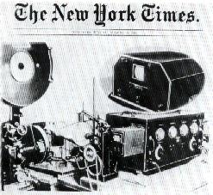  Above is the world's first television set invented by Manfred von Ardenne in 1931. See the book "Die Erinnerungen" by Manfred v. Ardenne. | 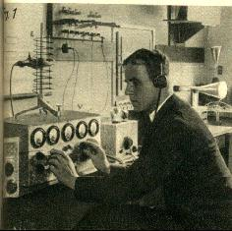  Hans E. Hollmann working in the Heinrich Hertz Institute in 1929. A CRT (Braun tube) is in the background.  Below is a clipping out of Watson Watt's book, "Applications of the Cathode Ray Oscillograph in Radio Research" published in 1933. The books give v. Ardenne much of the credit for perfecting the CRT. In 1929 and 1933 Watson Watt visited Hollmann and v. Ardenne in Berlin and was inspired by their work. He purchased over 100 CRT's from v. Ardenne.
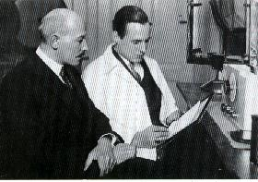  Dr. Loewe and v. Ardenne in 1928. Loewe financed v. Ardenne in the early years. Hollmann and von Ardenne had adjacent laboratories in Lichterfelde, Berlin. They were good friends from early childhood and worked together on many projects before and during WWII. | 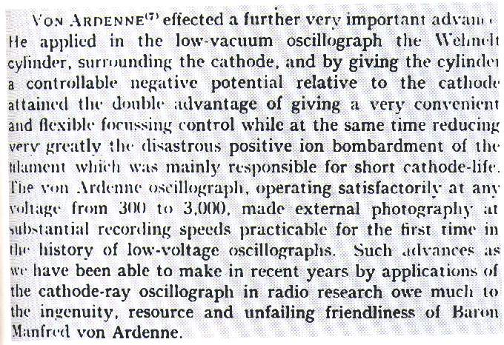
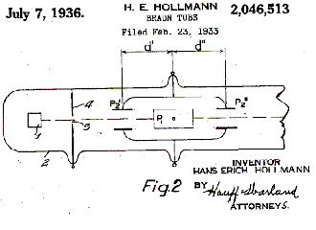 | Below are some of Hollmann's patents on CRT's including "Braun tube" modifications. Hollmann was the first one to recommend using the CRT for radar at GEMA and despite the objections of the Navy it was the correct thing to do according to Erbsloeh.  Hollmann and v. Ardenne worked on the Plane Position Indicator, PPI, used in the "Panorama" radars. In 1936, at a conference at Bad Salszbrunn, von Ardenne proposed using the polar-coordinate-oscilligraph for radar. The PPI is used on all modern radar sets today. See radar development in Germany for the first "Panorama" radar in the world that used the PPI.
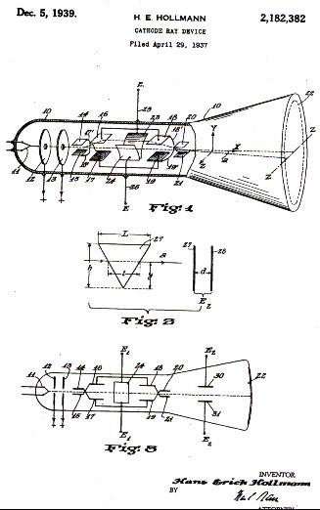 | 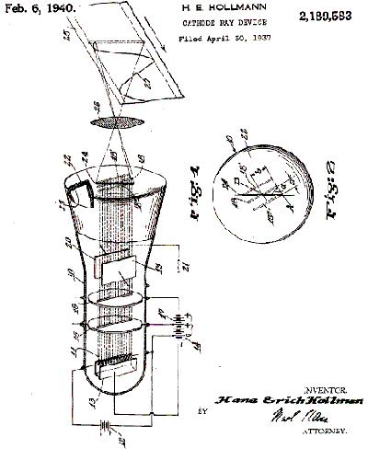
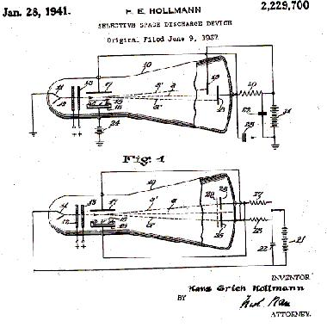 | 